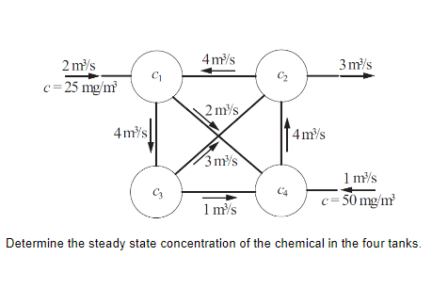**Problem Statement:** Determine the steady state concentration of the chemical in the four tanks.

**Solution:**

Four mixing tanks are connected by pipes.

Applying overall mass balance to the system, we get

$$v_{i}\frac{ⅆC_{i}}{ⅆt}=∑{\left(QC\right)}_{in}-∑{\left(QC\right)}_{out}$$

Where $v_{i}$ is volume of the tank i, Q is volumetric flow rate and C is concentration.

Applying this equation to each tank, we get

$$v_{1}\frac{ⅆC_{1}}{ⅆt}= - 6C_{1}+4C_{2}+2⋅25$$

$$v_{2}\frac{ⅆC_{2}}{ⅆt}= -7C_{2}+3C_{3}+4C_{4}$$

$$v_{3}\frac{ⅆC_{3}}{ⅆt}= 4C_{1}-4C_{3}$$

$$v_{4}\frac{ⅆC_{4}}{ⅆt}= 2C_{1}+C_{3}-4C_{4}+1⋅50$$

At steady state $v_{i}\frac{ⅆC_{i}}{ⅆt}=0$; thus, we get

$$4C_{1}-4C_{3}=0$$

$$2C_{1}+C_{3}-4C_{4}+50=0$$

$$- 6C_{1}+4C_{2}+50=0$$

$$-7C_{2}+3C_{3}+4C_{4}=0$$

We can solve these four linear equations using Gauss Elimination method.